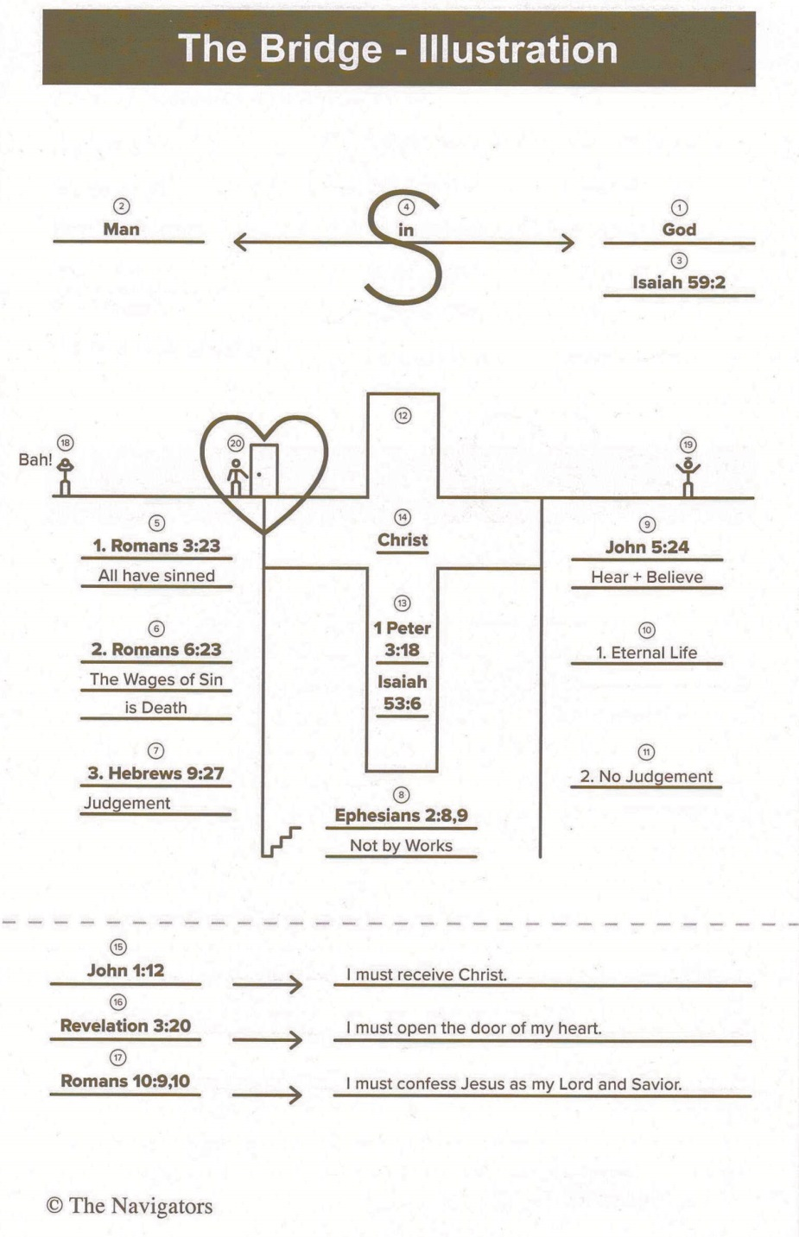

Two Rivers Church

326 E Guadalupe Rd, Gilbert, AZ 85234

[www.2RiversChurch.org](http://www.2RiversChurch.org)



Two Rivers Church

326 E Guadalupe Rd, Gilbert, AZ 85234

[www.2RiversChurch.org](http://www.RaptureCentral.com)

**Q# 1:** Have you come to the place in your spiritual journey where you know for certain that if you died tonight you would go to heaven? Or are you still working on that?

**Q# 2:** Suppose you were to die tonight and you were to stand before God face-to-face and He were to ask you,” Why should I let you into My Heaven?” What would you say to Him?

**1) God – Creator Of The Heavens, Earth, DNA, Plants, Fish, Birds, & Animals**

**2) Man – Created In The Image Of God With Free Will & For Fellowship w/God**

**3) Isaiah 59:2 –** “But your iniquities have separated you from your God; your sins have hidden his face from you, so that he will not hear you.”

**4) Sin – Separates Us From God**

**5) Romans 3:23 – All Have Sinned - “**For all have sinned and fall short of the glory of God”

**6) Romans 6:23 – The Wages of Sin is Death -** **“**For the wages of sin is death, but the gift of God is eternal life through Christ Jesus our Lord.”

**7) Hebrews 9:27 – Judgement -** **“**Just as people are destined to die once, and after that to face judgment”

**8) Ephesians 2:8,9 – Not by Works -** “For it is by grace you have been saved, through faith — and this is not from yourselves, it is the gift of God—not by works, so that no one can boast.”

**9) John 5:24 – Hear + Believe -** “Very truly I tell you, whoever hears my word and believes him who sent me has eternal life and will not be judged but has crossed over from death to life.”

**10) Eternal Life**

**11) No Judgement**

**12) The Cross**

**13) A. 1 Peter 3:18 – “**For Christ also suffered once for [all] sins, the righteous for the unrighteous, to bring you to God. He was put to death in the body but made alive in the Spirit”

**13) B.** **Isaiah 53:6 – “**We all, like sheep, have gone astray, each of us has turned to our own way; and the Lord has laid on him the iniquity of us all.

**14) Jesus Christ – Our Redeemer And Bridge Back To Fellowship With God**

**15) John 1:12 – I Must Receive Christ -** “Yet to all who did receive him, to those who believed in his name, he gave the right to become children of God …born of God.”

**16) Revelation 3:20 – I Must Open The Door Of My Heart -** “Here I am! I stand at the door and knock. If anyone hears my voice and opens the door, I will come in and eat with them, and they with me.”

**17) Romans 10:9,10 – I Must Confess Jesus Christ As My Lord And Savior -**

“If you declare with your mouth, "Jesus is Lord," and believe in your heart that God raised him from the dead, you will be saved. For it is with your heart that you believe and are justified, and it is with your mouth that you profess your faith and are saved.”

**18) BLAH!, 19) Redeemed, Or, 20) Ready to Open The Door Of Your Heart?**

**Q# 3: In Your Spiritual Journey, of these three, Where Do You Stand?**

**Q# 1:** Have you come to the place in your spiritual journey where you know for certain that if you died tonight you would go to heaven? Or are you still working on that?

**Q# 2:** Suppose you were to die tonight and you were to stand before God face-to-face and He were to ask you,” Why should I let you into My Heaven?” What would you say to Him?

**1) God – Creator Of The Heavens, Earth, DNA, Plants, Fish, Birds, & Animals**

**2) Man – Created In The Image Of God With Free Will & For Fellowship w/God**

**3) Isaiah 59:2 –** “But your iniquities have separated you from your God; your sins have hidden his face from you, so that he will not hear you.”

**4) Sin – Separates Us From God**

**5) Romans 3:23 – All Have Sinned - “**For all have sinned and fall short of the glory of God”

**6) Romans 6:23 – The Wages of Sin is Death -** **“**For the wages of sin is death, but the gift of God is eternal life through Christ Jesus our Lord.”

**7) Hebrews 9:27 – Judgement -** **“**Just as people are destined to die once, and after that to face judgment”

**8) Ephesians 2:8,9 – Not by Works -** “For it is by grace you have been saved, through faith — and this is not from yourselves, it is the gift of God—not by works, so that no one can boast.”

**9) John 5:24 – Hear + Believe -** “Very truly I tell you, whoever hears my word and believes him who sent me has eternal life and will not be judged but has crossed over from death to life.”

**10) Eternal Life**

**11) No Judgement**

**12) The Cross**

**13) A. 1 Peter 3:18 – “**For Christ also suffered once for [all] sins, the righteous for the unrighteous, to bring you to God. He was put to death in the body but made alive in the Spirit”

**13) B.** **Isaiah 53:6 – “**We all, like sheep, have gone astray, each of us has turned to our own way; and the Lord has laid on him the iniquity of us all.

**14) Jesus Christ – Our Redeemer And Bridge Back To Fellowship With God**

**15) John 1:12 – I Must Receive Christ -** “Yet to all who did receive him, to those who believed in his name, he gave the right to become children of God …born of God.”

**16) Revelation 3:20 – I Must Open The Door Of My Heart -** “Here I am! I stand at the door and knock. If anyone hears my voice and opens the door, I will come in and eat with them, and they with me.”

**17) Romans 10:9,10 – I Must Confess Jesus Christ As My Lord And Savior -**

“If you declare with your mouth, "Jesus is Lord," and believe in your heart that God raised him from the dead, you will be saved. For it is with your heart that you believe and are justified, and it is with your mouth that you profess your faith and are saved.”

**18) BLAH!, 19) Redeemed, Or, 20) Ready to Open The Door Of Your Heart?**

**Q# 3: In Your Spiritual Journey, of these three, Where Do You Stand?**